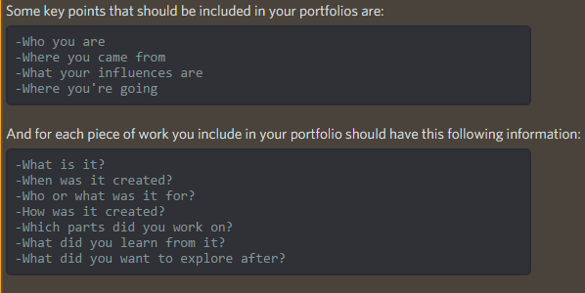

Tamatrashi – page 1

You are now the caretaker of your own Tamatrashi: a digital pet that you can access on your computer! They love your attention! However, it turns out your beloved pet is actually kind of a brat and is very touchy. Make them happy! You’ve got to, you’re their parent! Who said this would be easy...or even plausible. You’ll soon find that raising your very own Tamatrashi isn’t as fun as you thought it would be.

Tamatrashi is a basic pet caring game. The players have to keep their pet’s statistics high while managing their money at the same time. This game was made so that the player cannot win. We studied the philosophical idea of absurdism and was tasked with making an absurd game.

March – June 2018

My role was the developer and graphic artist

Tamatrashi – page 2

<p>Absurdism is a philosophical idea that refers to the conflict between a goal and the inability to reach said goal. Sisyphus is a man who has been condemned to push a boulder up a hill but have it roll back to the bottom again. Albert Camus wrote *The Myth of Sisyphus* and introduces his philosophy of the absurd and argues that Sisyphus is happy even if he is condemned to repeat the same meaningless task, never to accomplish it.</p>

<P>In terms of making a game absurd, we had to look at games we thought allowed the players to enjoy the game but is impossible to accomplish the given goal. Some games we explored was Saved the Date and Tickets Please. These games are both unique because no matter what the player does, they will always lose, and they don’t find out that they can’t win until they play for a while. </p>

<p>Save the Date is played like a graphic novel where a story is written out and the player chooses different options. In this game, the player is initially given the task to go out on a date but later finds out that he needs to save them from bizarre happenings. </p>

<p>Papers, Please places the player in the role of an immigration inspector. You inspect documents provided by the immigrants and allow them to legally pass, turn them down, or allow them to pass with consequences to your paycheck that goes towards caring for your family. As the game progresses, the player is given more restrictions for documents and less money per immigrant while bills increase. </p>

<p>We wanted to draw some inspiration from other genres of game besides survival. We eventually came to a game that several of us played in the past, Tomogatchi games from Bandai. We wanted to put a lot of different ideas to make the game in depth but had to cut back because of time restraints and unnecessary features. </p>

Tamatrashi – page 3

This game idea had a lot of inspiration from Tamagotchi and wanted to stay true to the original game we all played when we were younger. We wanted a pixel-art approach for the game and a simple User Interface. We wanted the players to realize that no matter what they do, they can’t satisfy their tamatrashi. In order to achieve that goal (and to get the game done in time) we focused more on trying to get the idea of absurdism across rather than creating more games within this game like the traditional Tamagotchi game.

Tamatrashi was developed in Unity and the assets were created on adobe photoshop/illustrator. Everything was created and designed by the team using online tutorials for help when needed.



Tamatrashi – page 4

Tamatrashi reflection, grab some stuff out of the GDD and add its link

Click here to download the game!

Anti-establishment – page 1

Anti-Establishment Project - Classified Files

**What is this game? What was the point?**

Anti-Establishment was a class project where we were to design an alternate reality game that covers the social justice problem of environmental impact.

**Links to the important website**

<http://anti-establishment.dx.am/>

**Dates and role**

March – June 2018

My role was website designer and developer as well as prop design and creation

Anti-establishment – page 2

**What I worked on:**

Show PDFs of the wireframe and documentation design. Print version too.

Websites, documents, etc

Anti-establishment – page 3

**My role during the presentation:**

I was the video camera person and recorded the footage used in the final production video. I followed the guy around. I need to get the youtube video and insert it in

<https://www.youtube.com/watch?v=2yOEXXb2rrk&feature=youtu.be>

Anti-establishment – page 4

**Reflection**

One of the main things that people learn early on is that we need to learn to do things ourselves. The roles that I was given in this project helped expand my knowledge in small yet crucial things to make the best product we could. I did a lot of research and looked at a lot of official forms online before making the autopsy report and environmental audit forms.